Southwest & Central Asia Country Project

Choose a country: __________________________________________________________
Due Date: _________________________________________________________________

Part I: Create A Map
-On a poster size piece of paper (Landscape or Portrait)
-Outline of your country
-5 most populated cities (Put in numbers, 1=most populated in country)
-Capital (Put a star next to it)
-Highest and lowest elevation points – Name the places and give their elevation in feet
-Major bodies of water in the country (Sea, Lake, River, Ocean, Etc.)
-Major bodies of water surrounding the country (Sea, Lake, River, Ocean, Etc.)
-Surrounding countries - Label
-5 Facts:
- Population
- Who is the leader and what is his/her title
- 1 famous person from this country and what they did
- Biggest export (Good produced in the country and sold within the country and to other parts of the world)
- 1 other interesting fact
-Colorful
-Decorate the map and make it more appealing anyway else you want to
Part II: Journal Entries/If I Lived In This Country
-Pretend you are a young man or woman living in your country
-Write three journal entries about your life in this country
1. General/Family/Home -- How many people are in your family? Who are they and how old are they? What do they do? What city do you live in and what is the city like? Landscape of city? What does your home look like (Outside, Inside)? What do you wear?
2. School/Work – Do you go to school? Where? What is it like? What do you learn? Or you may not go to school, if you don’t, what is your job? How much do you earn?
3. Culture -- Write about some things you do in your free time. Where do you hang out with friends and what do you do? Where do you go eat? What are some of your favorite foods? Do you play any sports? Do you practice your religion? Create art? Music or movies you listen to or watch?
-Each journal entry should be at least 7 sentences
-Make sure you proofread - Spelling/Punctuation/Capitalization/Grammar/Etc. will count
-Be creative

Bonus Points:
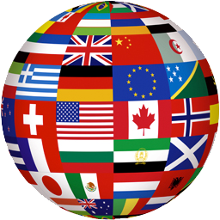
-Create a portrait of your family and where you live (City and structure you live in) – Must be on a poster size piece of paper

