Letters About Literature

“How did an author’s work change your view of the world or yourself?

About the Contest
Letters About Literature is a reading and writing contest for students in grades 4-12. Students are asked to read a book, poem or speech and write to the author (living or dead) about how the book affected them personally. Letters are judged on state and national levels. Tens of thousands of students from across the country enter Letters About Literature each year. If you are in grades 4-12, you are eligible to enter the Letters About Literature reading and writing contest.
The 2015-2016 Letters About Literature contest for young readers is made possible by a generous grant from the Dollar General Literacy Foundation, with additional support from gifts to the Center for the Book in the Library of Congress, which promotes the contest through its affiliate Centers for the Book, state libraries and other organizations.

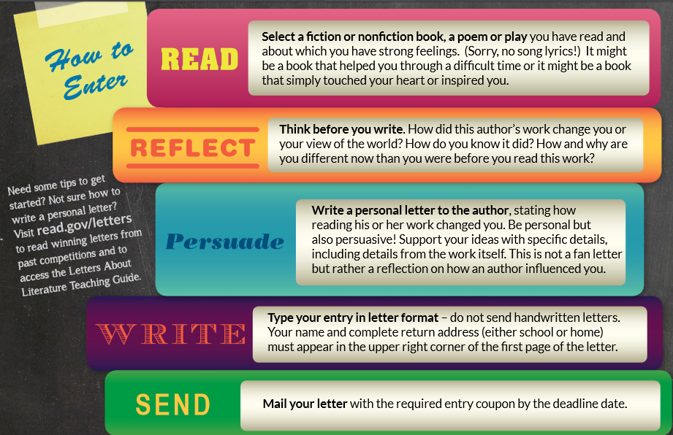

Websites:
- Main Website http://read.gov/letters/
- Rules & Information http://read.gov/documents/LAL16-Guidelines.pdf
How They Will Be Critiqued:
- Audience
- Purpose
- Grammatical Conventions
- Originality
Judged at a state level and then nationwide against other participants from 4th, 5th, and 6th grade

Due Date: January 9th, 2017 (The day we return from Christmas Break) to Miss Haifleigh
**This is an extra credit opportunity for both English and Literature. Students do not have to complete this assignment if they do not have time or do not want to. Miss Haifleigh would be happy to help with and/or proofread entries along the way**

